**7-Day Cultural & Tech Explorer: in Shanghai, Suzhou, and Hangzhou**

***A perfect experience meticulously crafted for Thai students, integrating scientific exploration, magical adventures and classic culture.***

**Tour Highlights**

* **🏙️ Dual Charms: Futuristic Cities & Ancient Water Towns**  
  Experience the essence of East China, from Shanghai's futuristic skyline to Suzhou's classical gardens and Hangzhou's poetic West Lake.
* **🚀 Top-Tier Science & Innovation**  
  Exclusive access to Shanghai Astronomy Museum, Hangzhou tech exhibition with study courses, and Maglev train experience to ignite a passion for science.
* **🎡 A Full Day of Magic & Fantasy**  
  A full day of immersion in the fairy-tale world of Shanghai Disneyland to create unforgettable family memories.
* **🧠 Learning by Doing: Integrated Study Tours**  
  Perfectly blends travel and education, with exploratory tasks at key sites, turning the journey into a moving classroom.
* **🏮 Cultural Immersion & Deep Experiences**  
  Personally experience the charm of Jiangnan culture through night tours, ancient street walks, and lake cruises.

**✈️ Your Gateway to Shanghai**

**→ ARRIVE** 9C 7422 | BKK 13:50 - PVG T2 19:10  
**← DEPART**  9C 8755 | PVG T2 19:55 - BKK 00:15

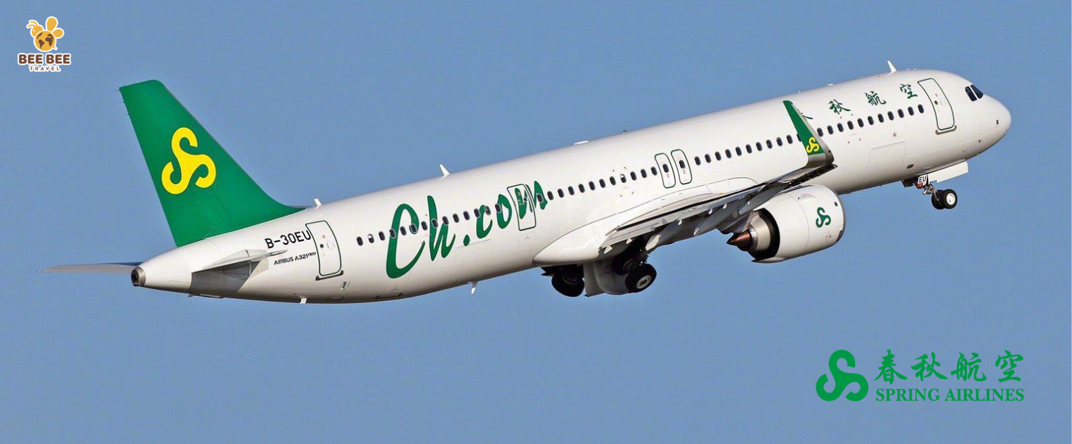

**📒 Full Itinerary Briefly**

|  |  |  |  |  |  |
| --- | --- | --- | --- | --- | --- |
| Day | Theme & Highlights | **Meals** | | | **Hotel** |
| **D1** | **Arrival & Modern Shanghai First Glimpse** **Evening:** Arrive at Shanghai Pudong (PVG) Airport. Check in to hotel |  | ✈️ | 🍽 | 图标  AI 生成的内容可能不正确。 |
| **D2** | **Magical Day at Shanghai Disneyland** **Full Day:** Full day immersive experience at Shanghai Disneyland, including the "Ignite the Dream" night castle show. | 🍳 | ❌ | ❌ | 图标  AI 生成的内容可能不正确。 |
| **D3** | **Hangzhou Tech Innovation & City Lights** **Morning: Visit the Shanghai Astronomy Museum**  **Afternoon: Travel to Suzhou**  **Evening: Panmen Scenic Area (Night Tour)** | 🍳 | 🍽 | 🍽 | 图标  AI 生成的内容可能不正确。 |
| **D4** | **Suzhou Classic Tour**  **Morning:** Visit **Suzhou Museum**  **Afternoon:** After lunch, visit the **Humble Administrator's Garden**, an ancient garden in the Jiangnan region of China  **Evening:** Stroll along **Pingjiang Road Pedestrian Street** in the ancient town of Suzhou | 🍳 | 🍽 | ❌ | 图标  AI 生成的内容可能不正确。 |
| **D5** | **Hangzhou Classic Tour** **Morning:** Bus **to Hangzhou and visit Lingyin Temple**  **Afternoon:**  Visit **Lingyin Temple**, **West Lake boat cruise, Hangzhou Lakeside Yintai in77**  **Evening:** Visit **Qianjiang New City Terrace** for the spectacular light show. | 🍳 | 🍽 | ❌ | 图标  AI 生成的内容可能不正确。 |
| **D6** | **Hangzhou Science and Technology Exploration Tour**  **Morning: Visit the exhibition halls of Hangzhou's top technology companies + study tour**  **Afternoon: Hangzhou Natural History Museum**  **Evening:** the Bund for **nighttime views** (panoramic photo spots). | 🍳 | 🍽 | 🍽 | 图标  AI 生成的内容可能不正确。 |
| **D7** | **Farewell and Departure:**  **Morning:** Enjoy free time at **Nanjing Road Pedestrian Street** for last-minute shopping.  **Afternoon: Visit the Maglev Science and Technology Museum. Experience the Maglev train to Pudong Airport and board your flight for departure.** | 🍳 | 🍽 | ❌ |  |

**Full Detailed Daily Itinerary**

**Day 1: Arrival in Shanghai - The Pulse of a Metropolis**

* **Evening (19:10):** Arrive at Shanghai Pudong International Airport (PVG), meet your professional guide.

**·Accommodation:** **Shanghai Sanjiagang Greenland THE QUBE Hotel (or similar) ★★★★** |

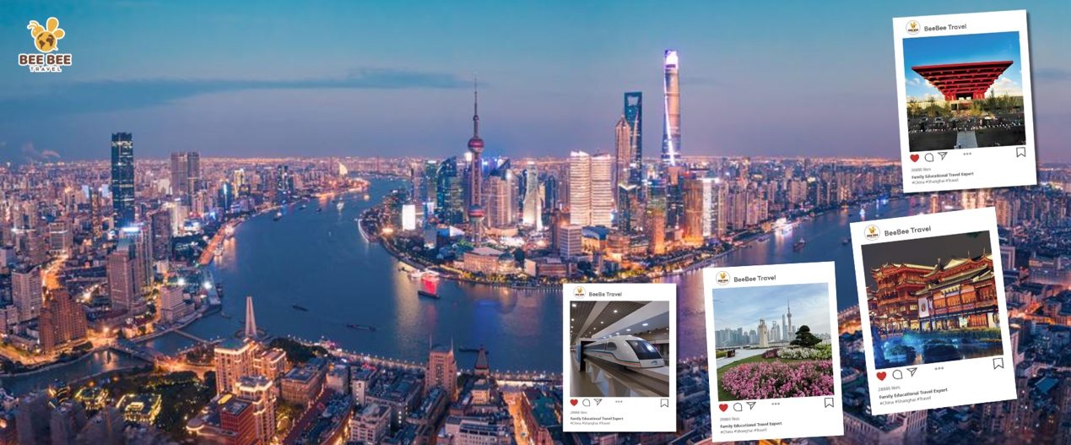

**Day 2: Shanghai - A Magical Day at Shanghai Disneyland** 🏰

* **Full Day (09:00 - 21:00):** Embark on a magical journey at **Shanghai Disneyland**.
  + Explore themed lands, enjoy rides, watch parades, and meet characters.
  + Culminates with the breathtaking **"Ignite the Dream"** nighttime castle spectacular.
* **Meals:** Breakfast at the hotel. Lunch and dinner at your own expense in the park.
* **Accommodation:** **Shanghai Sanjiagang Greenland THE QUBE Hotel (or similar) ★★★★** |

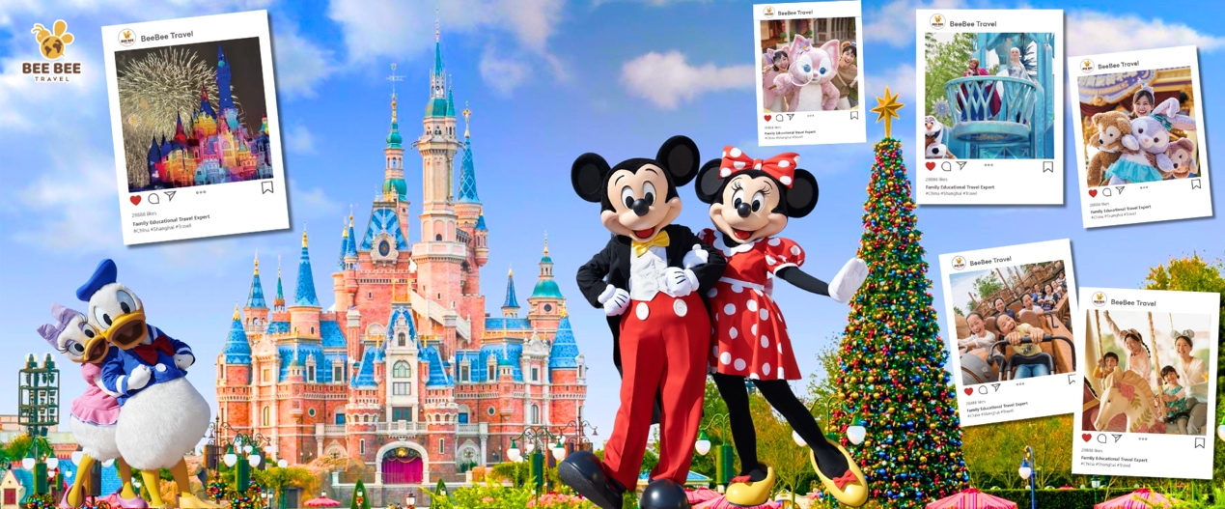

**Day 3: Shanghai to Suzhou - A Cultural Experience of Ancient Towns in Jiangnan, China** 🚀→🌙

**Cultural Fusion - A Blend of Astronomy and Humanities**

* **Morning (09:00-12:00):** Visit the world's largest planetarium, **Shanghai Astronomy Museum**. Journey from Earth to the cosmos in the "Home," "Universe," and "Odyssey" galleries.
* **Afternoon (13:30-14:30):** Take a high-speed train to the ancient city of **Suzhou**.
* **Evening (19:00-20:30):** **Night tour of Panmen Scenic Area**. See China's only preserved land-and-water city gate under atmospheric lighting.
* **Accommodation: Pan Pacific Suzhou WuGong Hotel (or similar) ★★★★**

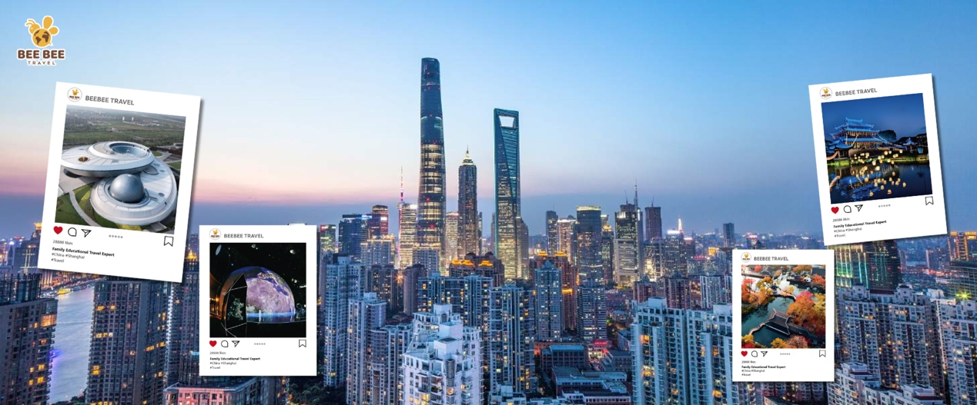

**Day 4: Garden Classroom & Suzhou's Canals** 🏞️

**·Morning (09:00 - 12:00):Suzhou Museum - Visit the Suzhou Museum designed by I.M. Pei, a perfect blend of art and tradition.**

**·Afternoon (13:00 - 17:00):Humble Administrator's Garden - Visit the Humble Administrator's Garden and appreciate the exquisite elegance of a Jiangnan garden.**

**·Evening (18:00 - 20:30):Pingjiang Road Pedestrian Street - Stroll along the ancient Pingjiang Road and experience the slow-paced life of traditional houses with their bridges and waterways.**

**·Taste Suzhou cuisine and experience authentic Suzhou flavors.**

**·Accommodation: Pan Pacific Suzhou Wugong Hotel (or similar) ★★★★**

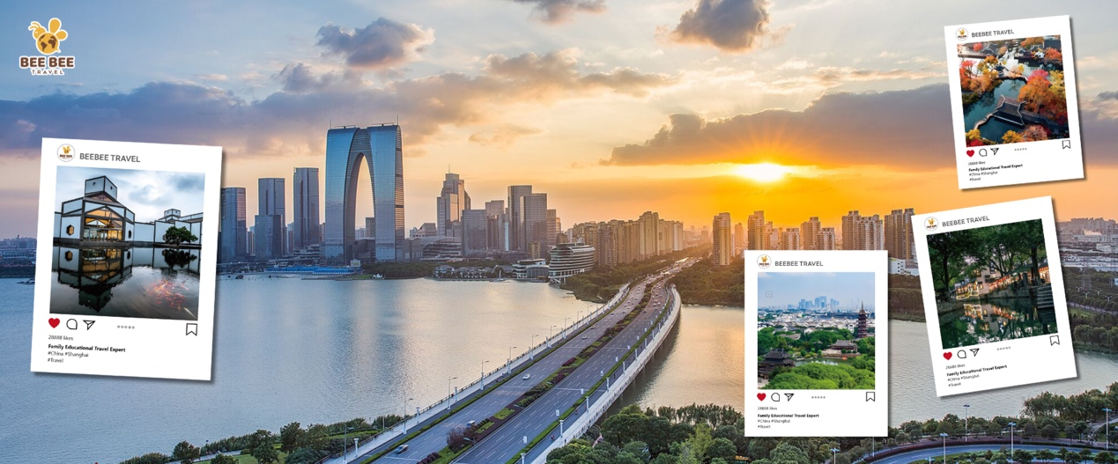

**Day 5: Hangzhou's Poetry: Temple & Lake Cruise** 🛶

**·Morning (08:00 - 11:00): Take the high-speed train directly to Hangzhou, visit the ancient Lingyin Temple, and pray for peace and good fortune.**

**·Afternoon (12:30 - 16:00): Enjoy a boat tour on West Lake, experiencing the poetic beauty of this "paradise on earth." Admire classic scenic spots such as the Broken Bridge and Viewing Fish at Flower Harbor.**

* **Accommodation:** Comfortable Hotel in Hangzhou

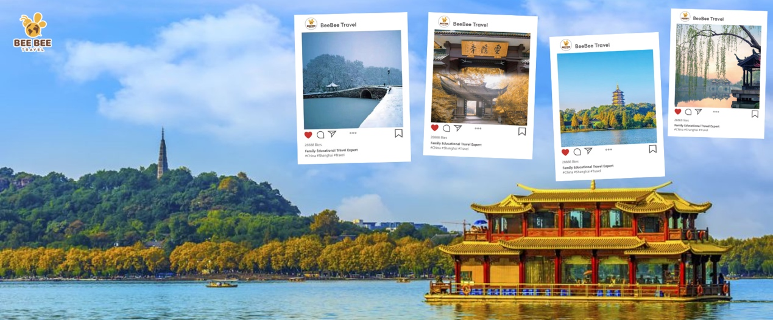

**Day 6：Tech Innovation & Study Day in Hangzhou** 💡

**· In-depth Technology Experience - From Robots to Artificial Intelligence Systems**

**· Professional Networking - Direct Communication with Technology Experts**

**· Hands-on Learning - Multiple Interactive Experience Stations**

**· Cultural Integration - A Perfect Blend of Technology and Traditional Experiences**

**Morning (08:00 - 12:00): Travel to Hangzhou. Visit the exhibition halls of top Hangzhou companies.**

**Exhibition Area Contents:**

***Digital Exhibition Hall Experience:***

***"Six Dragons" Innovation Wall***

***Interactive Touchscreen Display***

***Breakthrough Technology Display***

**Future Technology Zone:**

***Artificial Intelligence Interactive Station***

***Extended Reality Experience Zone***

***Smart Living Lab***

***Digital Art Space***

**Afternoon (14:30 - 17:00): After lunch,Visit the Natural History Museum to learn about natural ecology and the mysteries of life.**

**Accommodation: Hangzhou FlyZoo Hotel (or similar) ★★★★**

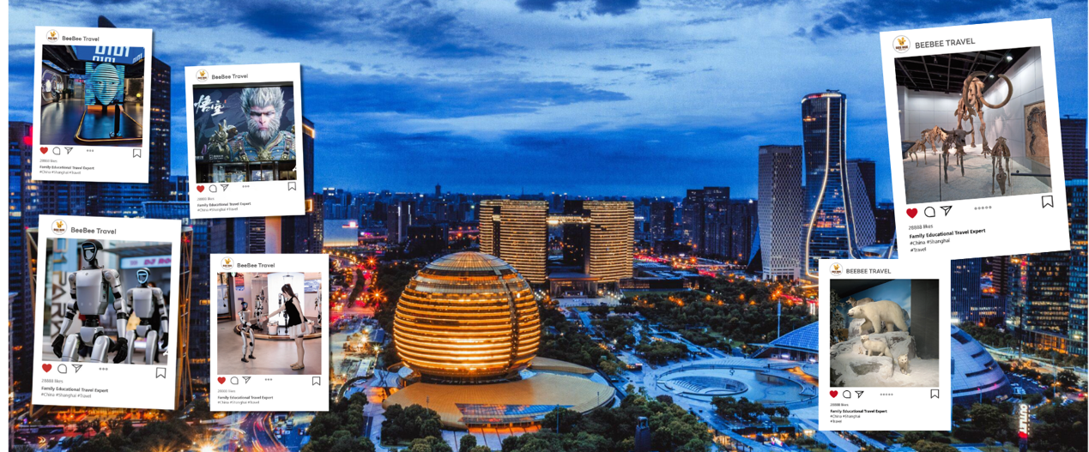

**D7：Departure from Shanghai - A final experience of humanity's fastest mode of transportation** 🚄

* **Morning (09:30-11:00):** Return to Shanghai. Visit the **Shanghai Maglev Museum** to learn the science behind the train.
* **Late Morning (11:15-11:40):** **Special Experience:** Ride the **Maglev Train** to Pudong Airport, experiencing the 430 km/h journey!
* **Noon (12:00):** Arrive at PVG. Your guide assists with check-in. A light meal/snack box is provided.
* **Evening (19:55):** Board your flight back to Bangkok, concluding a wonderful study tour.

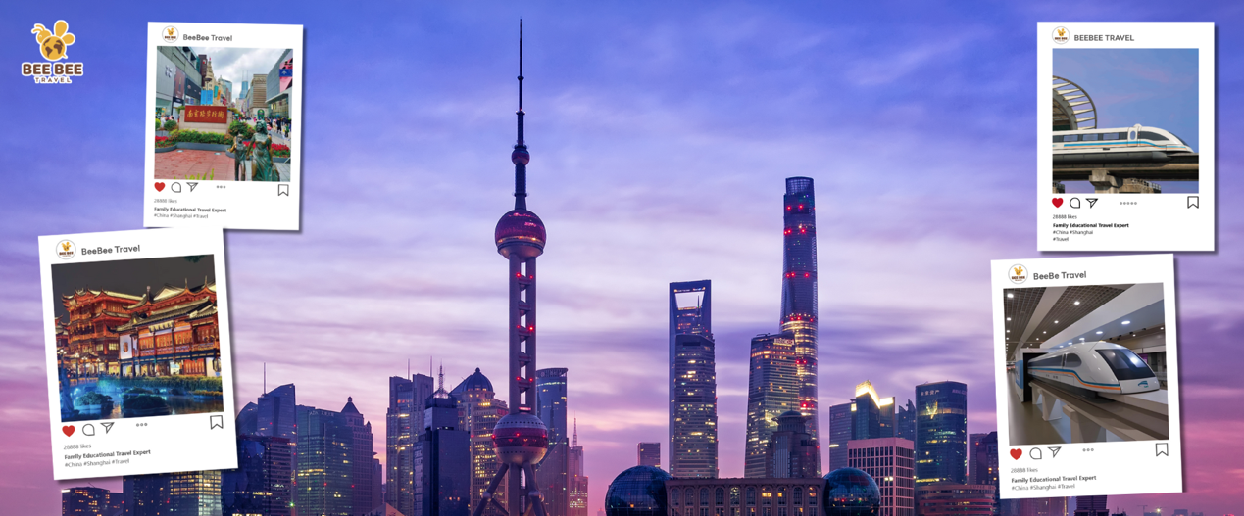

**What's included**

**✅ Cars Vehicle fees during the tour: Vehicle type determined by final group size.**

**✅Transfers Destination transfer service: Shared vehicle pick-up and drop-off.**

**✅Accommodation Standard hotel room (2 guests) Accommodation at hotels listed in the itinerary.**

**✅Catering Included for adults: 15 meals (breakfast*7 Lunch/Dinner 8)**

**✅Tickets and activities Admission ticket to the main entrance of the attraction/venue listed in the itinerary**

**✅ Tour guide Local Mandarin and English-speaking tour guide.**

**❌ Additional fees Transportation and storage fees for overweight baggage.**

**❌Personal expenses such as laundry, haircuts, telephone, fax, pay-per-view TV, beverages, tobacco, and alcohol at the hotel.**

**❌Transportation and accompanying services during free time.**

**❌All personal expenses and any fees not mentioned in the inclusions.**

**❌Single room supplement for this product, to ensure the best possible travel experience, room sharing is not available for solo travelers. The price quoted is for 2 adults sharing 1 room. When booking, please select the number of rooms and single room supplements based on your requirements. For this product, you can request a triple room or an extra bed. If three adults will share a room, please note it when booking. A customer support agent will confirm availability and any additional fees. (Please note: Rooms in local hotels may be small, and adding an extra bed could affect your comfort.)**

**Important Notes & Travel Tips**

* **Group Travel:** This is a group tour, and punctuality is essential to ensure the smooth operation of the itinerary for all participants.
* **What to Pack:** Comfortable walking shoes are a must. Please check the weather forecast and pack accordingly. A power adapter for Chinese sockets (Type A/C) is recommended.
* **Money Matters:** The local currency is the Chinese Yuan (CNY). It is advisable to carry some local currency for small personal purchases. Major credit cards are widely accepted in shopping malls.
* **Free Time:** Some free time for shopping and personal exploration is built into the itinerary. Please follow the guide's instructions regarding meeting points and times.
* **Dietary Needs:** Please inform us of any specific dietary requirements (e.g., vegetarian, food allergies) at the time of booking.

**Visa Information**

* **Thai Nationals:** Thailand passport holders are eligible for **visa-free entry** into China for tourism for a stay of up to 30 days. Please ensure your passport is valid for at least 6 months from your date of entry.
* **Non-Thai Nationals:** For guests holding other passports, visa regulations differ. **Please consult with our customer service team BEFORE booking** to confirm visa requirements. If a visa is required, we can assist with the application process, and all associated fees will be charged separately.

**Penalty**

**Travel agency breach of contract:**

If the contract is terminated before the trip, the travel agency will refund all collected travel fees to the user. A penalty fee will be paid in accordance with the following standards:

|  |  |
| --- | --- |
| Before The Trip | Penalty |
| 25 days before departure | 5% |
| 14 days before departure | 30% |
| 7 days before departure | 50% |
| 1 days before departure | 60% |
| 0 days before departure | 80% |

If compensation paid according to the ratios detailed above is not sufficient to compensate the traveler's actual losses, the travel agency should provide compensation according to the traveler's actual losses.

**Traveler breach of contract**

Penalties for breaking the contract before the date of travel are calculated as follows:

|  |  |
| --- | --- |
| Before The Trip | Penalty |
| 25 days before departure | 5% |
| 14 days before departure | 30% |
| 7 days before departure | 50% |
| 1 days before departure | 60% |
| 0 days before departure | 80% |

If the actual fees charged to the traveler are higher than the fees shown above, the traveler should pay the actual fees charged, but this amount should not be higher than the total travel fees.  
As some travel items need to be booked in advance for this route, cancellations at a time other than the period between the group being formed and 6 day(s) before departure may incur loss without refund of plane tickets, hotel bookings, or other booked items. If the traveler needs to cancel a booking, the traveler should contact the travel agency as soon as possible. The travel agency should help the traveler reduce losses if possible, and refund travel fees after losses and cancellation fees have been deducted. The travel agency is not responsible for further compensating the traveler for any losses.